
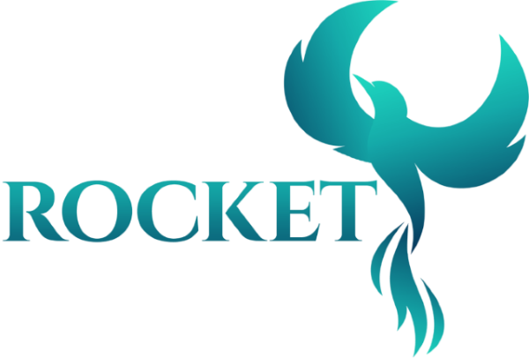

ROCKET Teacher Training

Critical Virtual Exchange – Extension Module Collaboration Work Sheet
Playful Pathways Towards Equity in Higher Education








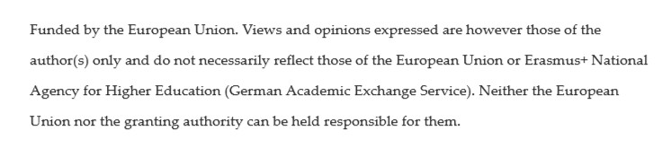
Welcome to ROCKET

ROCKET is an innovative project co-funded by the Erasmus+ Cooperation Partnerships program. It seeks to develop a working concept for Critical Virtual Exchange which implements Role-Playing Games and Conflict Transformation. These novel modes of online interaction can aid participants to take on new perspectives and
gain a deeper understanding of issues relating to Diversity, Equity, and Inclusion. In addition to students, the initiative offers educational formats aimed at teaching and administrative staff. Conceived by the universities

of Göttingen, Groningen, and Uppsala, ROCKET seeks to improve European Higher Education while also connecting to local communities.

For more information visit https://rocket-erasmus.eu/

Authors
Sake Jager | Riccarda Fulda

Graphic Design
Caterina Blomgren | Daria Shpak

This work is licensed under CC BY NC. To view a copy of this license, please visit www.creativecommons.org

This material was created within ‘ROCKET: Role Playing Games on Conflict Transformation for Equity in Higher Education through Virtual Exchange’, a joint Erasmus+ Higher Education Cooperation Partnership project in the Higher Education sector between the Universities of Göttingen, Uppsala and Groningen. https://rocket-erasmus.eu/

Funded by the European Union. Views and opinions expressed are however those of the author(s) only and do not necessarily reflect those of the European Union or OeAD-GmbH. Neither the European Union nor the granting authority can be held responsible for them.

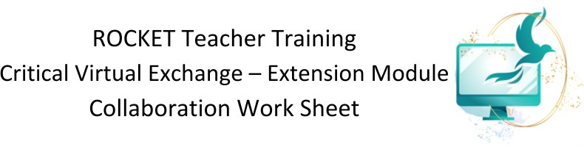

Introduction 2
Part 1 – What you expect from your collaboration 3
Activity: Questionnaire (individual) 3
Part 2 – Learning outcomes, activities, assessments – where do they differ, how can they meet? 5
Constructive alignment 5
Part 3 – Engaging in a critical perspective 7
International and intercultural dimensions 7
Cultural values and the role of language 8
Technologies 8
Part 4 – Project outline and practicalities 10
Activity: Project outline (collaborative) 10
Practicalities (optional, for future reference) 10

Introduction
As part of the Erasmus+ ROCKET Teacher training course, we designed a collaboration work sheet, which aims to offer a foundation for reflection and joint considerations when envisioning a CVE project with a teaching partner. The work sheet entails a brief questionnaire where interested lecturers who are thinking about working together in a CVE format can find out about each other´s expectations in a future collaboration via CVE. Furthermore, it supports lecturers in identifying learning outcomes, activities or forms of assessment for their joint project and addresses how taking a critical perspective can impact the planning and implementation of their CVE project.
There are two possible scenarios to work on this activity:

- Two lecturers / teaching staff from different locations can use this sheet to get their collaboration started and apply learnings to a CVE you are envisioning to teach as a team.
- If no partner has been identified yet, it may be of value to work on this sheet individually (without a partner) to prepare a project which is intended to be implemented together with a partner in the future. This may help the reflection process and narrowing down the process of finding a partner.

Part 1 – What you expect from your collaboration
Partners’ expectations about a VE project to be developed may differ considerably. Most of these differences may be overcome, but it is good to take stock of expectations at the start of the design.

Please complete this questionnaire separately at first and then compare and discuss your results.

Activity: Questionnaire (individual)
To what extent do you agree with the following statements? Write the corresponding number from the scale in the second column.
Scale:
1 = Strongly disagree, 2 = Somewhat disagree, 3 = I do not know yet, 4 = Somewhat agree, 5 = Strongly agree

1 General set up: | Answer
a. The CVE will take place during the exact same period in both courses
b. Students will work together at least once a week during the CVE
c. Students have the same level in the language they will use during the CVE
d. Students use each other’s mother tongue
e. Students have the same academic level (BA, MA, PhD)
f. The number of students in both groups are (almost) equal
g. The CVE is embedded in the Learning Management System of my course
h. I give my students advice about how to deal with possible time difference
2 Learning design:
a. The CVE project contributes to my students’ knowledge of specific course topics
a. The CVE contributes to my students’ intercultural communication skills
b. Both courses have similar learning outcomes for this VE
c. We focus on the intercultural experience of the students
d. The product that my students will deliver will be assessed
e. Students from both courses should be assessed by the same product
f. The product that my students will deliver will count in their final grade for the course
g. The grading of the product should be similar in both courses
h. Students reflect on what they have learned throughout the VE
i. Students from both courses will contribute equally in the process and to the product

3 Technology and practicalities
a. Students meet each other by video conferencing (such as Zoom, MS Teams, Google Meet)
b. Students work both synchronously and asynchronously
c. All students use the same technology during the VE
d. Students plan their own sessions with peers.

These questions are intended as conversation starters on crucial aspects of your CVE project.
In the meeting with your partner, compare your expectations, and try to agree on the general settings, learning design and technology use for your project.

Take notes of what you have reflected on.

Part 2 – Learning outcomes, activities, assessments – where do they differ, how can they meet?

Constructive alignment
Learning outcomes, activities and assessment should be aligned as much as possible. This process is called constructive alignment.

Your course may have specific learning outcomes, activities and assessment already. Since you aim to link your courses through collaborative work, consider the learning outcomes, activities and assessment which are relevant for your course and how they may be supported in the collaboration.
Alternatively, if you are setting up a collaboration project for a new course, think of learning outcomes, activities and assessment to be defined for the courses and how the project aligns with these.

The activities part includes the description of the tasks which your students will do together. Identify which synergies may be created by bringing your courses together. Consider the students’ different national and cultural backgrounds, subject knowledge and possible other differences. Include activities where students from partners need each other to complete the activity.
Activity: Constructive alignment (individual and collaborative)
You may again want to complete this part this independently from each other, and discuss and reflect on the results in the meeting with your partner.

Learning outcomes
Partner A | Partner B
Reflection on synergies between your learning outcomes:
Teaching/learning activities
Partner A | Partner B
Reflection on synergies between your teaching/learning activities:

Assessment of student work
Partner A | Partner B
Reflection on synergies between your assessment tasks:

Part 3 – Engaging in a critical perspective

Activity: Critical perspectives (collaborative)
This part addresses various aspects related to Hauck’s CVE framework. Plan a synchronous meeting with your partner to complete this part of the form. If you have not done so yet, you may also consider putting the form on a shared drive to facilitate working on the text asynchronously.
Discuss these aspects during the meeting with your partner.

International and intercultural dimensions

What would the CVE add to your course that was not there before in terms of international and intercultural elements?
Partner A | Partner B
What would be your role as a teacher to raise awareness amongst students about international and intercultural differences?
Partner A | Partner B
How will you make sure to create a safe(r) learning space and include a perspective on Diversity, Equity & Inclusion in your planning process?
Partner A | Partner B
Is the project part of Internationalisation at Home initiatives in your institution?
Partner A | Partner B
Does your project involve the local communities / environments?
Partner A | Partner B
How is your project aligned with the UN SDGs?

Partner A | Partner B

Cultural values and the role of language

How will your CVE address …
- … cultural differences
- … diverse perspective to sensitive/conflicting topics
- … the impact of Diversity, Equity and Inclusion in learning
Partner A | Partner B
Will students face language difficulties when communicating in the project? How will you address such difficulties?
Partner A | Partner B

Technologies
Consider the digital tools you and your students will be using during your exchange. Think of video conferencing (synchronous) and tools for asynchronous collaboration.

How will you ensure accessibility to these technology tools for all students?
Partner A | Partner B
Are students allowed to select their own tools for communication, collaboration and co-creation?
Partner A | Partner B
Do you or your students need to comply with privacy and data security policies?
Partner A | Partner B

Will you provide training and support in using these tools?
Partner A | Partner B

Part 4 – Project outline and practicalities

Activity: Project outline (collaborative)
Please give a short description of your project (max 200 words). Include your name, institution and other relevant details in the box for each partner.

Project outline
Partner A | Partner B
[Description]

Practicalities (optional, for future reference)
These final questions relate to further practical aspects to be considered when preparing your project. You may leave these for now, but need to address them when you want to run the project for real.

Time management
- When will the course be running?
….
- Do you live in different time zones? Do you take this into account? If so, how?
Technology
- Which platform would you like to use?
….
- What kind of technical support do you have available?
….
Procedures
- How will the groups be created? (E.g. number of students from both universities, method of pairing)
….
- How will students be monitored throughout the activities?
….
- How are students going to hand in work?
….
- How are the responsibilities distributed amongst the partners? (E.g. is responsible for the development, monitoring and assessment)
...

