Elements Conflict Styles Assessment

Instructions

Consider your common reactions when something you want is different from what someone else wants.

For this exercise, consider how you would respond as a student at your university.

- For questions A-J, imagine your initial reactions to a hypothetical situation.
- For questions K-T, imagine your reactions to the same situation after the conflict has gotten more intense.

Do not think too much about the questions. Follow your first instinct.

Circle a number between 1-5 for each of the questions:

- I spend time listening to the other person’s perspective instead of voicing my own.

Uncommon for me 1 - 2 - 3 - 4 - 5 Common for me

- I try to discuss multiple options with the other person to try to find a good solution for everyone.
Uncommon for me 1 - 2 - 3 - 4 - 5 Common for me

- I offer to give the person part of what they want in exchange for part of what I want.

Uncommon for me 1 - 2 - 3 - 4 - 5 Common for me

- I debate with the other person to convince them I am right.

Uncommon for me 1 - 2 - 3 - 4 - 5 Common for me

- I change the subject away from the issue so the situation does not become uncomfortable.

Uncommon for me 1 - 2 - 3 - 4 - 5 Common for me

- I tell the person what I think they want to hear to keep the situation under control.

Uncommon for me 1 - 2 - 3 - 4 - 5 Common for me

- I contact the person multiple times in an effort to resolve the situation in a way that primarily benefits me.

Uncommon for me 1 - 2 - 3 - 4 - 5 Common for me

- I try to make sure everyone feels heard when discussing the issue, then find a solution everyone will find acceptable.

Uncommon for me 1 - 2 - 3 - 4 - 5 Common for me

- I don’t respond when the person attempts to contact me about the issue.

Uncommon for me 1 - 2 - 3 - 4 - 5 Common for me

- I take my time to explore all possible options to address the issue rather than moving forward with my initial thoughts.

Uncommon for me 1 - 2 - 3 - 4 - 5 Common for me

- I try to soothe the other person as much as possible and keep my own feelings to myself.
Uncommon for me 1 - 2 - 3 - 4 - 5 Common for me

- I avoid reading messages from the person about any topic.

Uncommon for me 1 - 2 - 3 - 4 - 5 Common for me

- I try to find ways to get what I want regardless of what the other person wants.

Uncommon for me 1 - 2 - 3 - 4 - 5 Common for me

- I negotiate with the person to find a quick solution that will resolve the issue for the time being.

Uncommon for me 1 - 2 - 3 - 4 - 5 Common for me

- I offer to give up something as long as the other person gives up something as well to be fair.

Uncommon for me 1 - 2 - 3 - 4 - 5 Common for me

- When this person is around, I try not to make eye contact or conversation.

Uncommon for me 1 - 2 - 3 - 4 - 5 Common for me

- I tell the person exactly what I am thinking and feeling without softening my wording or tone, even if it upsets them.

Uncommon for me 1 - 2 - 3 - 4 - 5 Common for me

- I research solutions that might benefit us both over an extended period of time, returning to the person regularly to discuss these options.

Uncommon for me 1 - 2 - 3 - 4 - 5 Common for me

- I spend time considering ways to adjust the situation to avoid upsetting the other person.

Uncommon for me 1 - 2 - 3 - 4 - 5 Common for me

- I consistently consider and suggest new strategies to address the issue to help find a way for everyone to win.

Uncommon for me 1 - 2 - 3 - 4 - 5 Common for me

--------

Now, complete the instructions on the next pages.

Place your score for each statement by its corresponding letter, e.g., D _4_

Then, add the two scores together, e.g., D _4_ + G _2_ = 6
Place the total in the grey box below the box with the letters.

D __  G __ | M __  Q __ | E __  I __ | L __  P __ | C __  H __ | N __  O __ | A __  F __ | K __  S __ | B __  J __ | R __  T __
Calm | Storm | Calm | Storm | Calm | Storm | Calm | Storm | Calm | Storm
Competing   |  | Avoiding  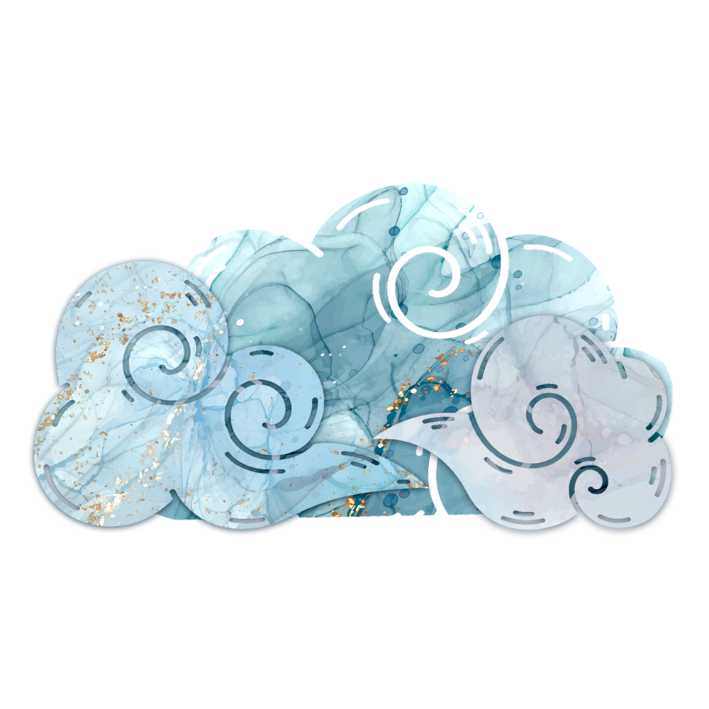 |  | Compromising   |  | Accommodating   |  | Collaborating  

The numbered questions refer to specific conflict styles,
e.g., Competing, Avoiding, Compromising, Accommodating, and Collaborating.

Place your totals for Calm under the first table from high to low.
Then, write the corresponding conflict style next to the score.
Do the same thing for Storm in the second table.

Calm  Response based on your initial reaction to a conflict |  |  | Storm  Response when a conflict has persisted over time and intensified
 | Total Score | Conflict style |  | Total Score | Conflict style
1st |  |  | 1st
2nd |  |  | 2nd
3rd |  |  | 3rd
4th |  |  | 4th
5th |  |  | 5th

My most used common style in times of Calm is: _______________________

My most used common style in times of Storm is: _______________________

My least used common style in times of Calm is: ________________________

My least used common style in times of Storm is: _______________________

------

This inventory was co-created by Evocative Games AB and the Erasmus+ Cooperation Partnership Role-Playing Games on Conflict Transformation for Equity in Higher Education through Virtual Exchange (ROCKET). Content has been adapted from the Thomas-Kilmann Inventory (1974) and Ron Kraybill’s Style Matters Inventory (2024).

References

Kraybill, Ron. 2024a. “Five Styles of Responding to Conflict.” Style Matters. RiverHouse ePress.

Kraybill, Ron. 2024b. “How to Manage Your Storm Shift in Conflict Resolution.” Style Matters. RiverHouse ePress.

Thomas, Kenneth Wayne, and Ralph H. Kilmann. 1974. The Thomas-Kilmann Conflict Mode Instrument. Mountain View, CA: CPP, Inc.

Images by Kate Blomgren and Daria Shpak.

This work is licensed under a Creative Commons
Attribution-NonCommercial-ShareAlike 4.0 International (CC BY-NC-SA 4.0)
For more information, please visit creativecommons.org




Funded by the European Union. Views and opinions expressed are however those of the author(s) only and do not necessarily reflect those of the European Union or OeAD-GmbH. Neither the European Union nor the granting authority can be held responsible for them.

